|  |
| --- |
| GFD 2 |

**Vietnam Forest and Deltas Program**

Fuelwood Value Chain Assessment

in Thanh Hoa and Nghe An Provinces

DRAFT FINAL REPORT

September 2014

**GFD Consulting & Development Ltd.**

Suite 705, 14 Tran Hung Dao, Hoan Kiem, Hanoi

Tel: 84 4 3926 4830

Email: anh.dh@gfd.com.vn

**CONTENTS**

[1 Introduction 3](#_Toc399149598)

[2 Method 3](#_Toc399149599)

[2.1 Clustering design 4](#_Toc399149600)

[2.2 Field survey 8](#_Toc399149601)

[3 Findings 9](#_Toc399149602)

[3.1 Residential fuelwood consumption 9](#_Toc399149603)

[3.2 Local industrial consumption 15](#_Toc399149604)

[3.3 Commercial activities of middlemen 16](#_Toc399149605)

[3.4 Discussion of total fuelwood consumption 18](#_Toc399149606)

[3.4.1 Discussion of fuelwood consumption in Lang Chanh district, Thanh Hoa 18](#_Toc399149607)

[3.4.2 Discussion of fuelwood in Nam Son commune, Quy Hop district, Nghe An 20](#_Toc399149608)

[3.5 Value chain assessment in relationship to forest degradation and deforestation 24](#_Toc399149609)

[4 Recommendations 25](#_Toc399149610)

[4.1 Urgent need for revision of land conversion in some specific area 25](#_Toc399149611)

[4.2 Urgent need for forest land administration in some specific area 25](#_Toc399149612)

[4.3 Improved stoves 25](#_Toc399149613)

[4.4 Stability of electricity supply 26](#_Toc399149614)

[4.5 Training on natural forest management skills for households 26](#_Toc399149615)

[4.6 Potential of using agriculture residues as an alternative to fuelwood 26](#_Toc399149616)

[4.7 Creation of fuelwood source 26](#_Toc399149617)

# Introduction

Vietnam is a developing country with 70% population living in the rural area, about three fourth of the land is located in the hilly and mountain area with long tradition of fuelwood as a main source of energy. Fuelwood are used in the households for cooking, heating and support to supplement business like alcohol brewing, food processing.

Woody biomass from forest is a renewable source of energy that can substitute for fossil fuels in the production of energy and other products, a potentially important tool in the national strategy to reduce greenhouse gas emissions. However as the rural population is continuously increased, the tradition of heavily dependence on fuelwood may increase the pressure on forest and thus lead to forest degradation and deforestation.

Understanding the dimension of fuel wood consumption, the structure and relationship of key stakeholders in the fuelwood supply and demand, and the consequences can help policy maker to design better energy supply system for rural population, mitigate the global warming and to reduce forest degradation and deforestation.

This study, funded by Vietnam Forests and Deltas project (VFD), is aiming to assess current situation and future trends of fuelwood consumption and exploitation, the value change of fuelwood and its relationship with forest degradation and deforestation, and identify key opportunities to design intervention that could lead to more effectively and sustainably use of fuelwood in the project area.

The study was conducted in 2 provinces Thanh Hoa and Nghe An during September 2014. At industrial level, the consultant team have surveyed several industrial factories that are using wood as fuel in two provinces. At community level, the consultant team conducted interviews with 215 households at 14 communes including 4 districts in Thanh Hoa and 3 districts in Nghe An. Interviews with local officers were also conducted to collect information on social economic condition, current regulation/ policy in forest protection and how it was enforced at local level.

This report present our findings in fuel wood demand side at household level, industrial level, and commercial activity of fuelwood. Finally the value chain of fuelwood and its relationship with forest degradation and deforestation is analyzed and discussed.

# Method

The field study was conducted from 18 to 26 August 2014. Before starting the field survey a desk review was carried out to collect information on the social economic condition as well as the forest resources of the study area. Key secondary data collected at commune level during the desk review are: population density, forest area, data related to climatic condition such as temperature and elevation. It contributed to design the questionnaire and number of samples.

A total of 221 households were selected using stratified random sampling procedure. The process of household selection includes: i) selection of cluster; ii) selection of commune from clusters; iii) selection of village from commune; iv) selection of households from village.

The reason to use cluster instead of district to start the selection process is that districts boundary are administrative unit that might not follow nature landscape and social economic condition that drive the behavior of fuelwood consumption. Therefore the design of survey starts firstly with clustering the study area into several stratums (clusters) that are homogenous in term of fuelwood consumption.

## Clustering design

For fuelwood consumption survey, it is recommended to use stratified sampling rather than simple random. This is because we know that the studied population can be physically divided in to homogenous groups with respect to biomass consumption. The stratified sampling, therefore, will lead to greater accuracy in the estimates of fuelwood consumption patterns (smaller estimation errors than simple random sampling with the same sample size).

For this study, following variables are used for stratification.

Table . Variables used for sample stratification

|  |  |  |
| --- | --- | --- |
| **Variable** | **Relation to biomass consumption** | **Data source** |
| Population density 2010 | Basic demographic characteristic, reflect the demand size of biomass consumption. | MONRE 2010 - Commune level population density |
| Mean elevation | Geographic character of a population in relationship with biomass source and consumption. People living in higher altitude usually consume more fuel wood for heating | Global ASTER Digital elevation model, resolution 30 m. Computed as mean value for each commune |
| Mean slope | Reflect the terrain condition and accessibility | Global ASTER Digital elevation model, resolution 30 m. Computed as mean value for each commune |
| Distance to road | Reflect the level of access to transportation | Distance to national road, inter-provincial road, inter-district road. Computed as mean value for each commune |
| Average annual temperature | Area with lower temperature would need more fuel wood for heating and cooking | WorldClim, global climate data at 1 km resolution. Computed as mean value for each commune |
| Min temp of coldest month | Area with lower temperature would need more fuel wood for heating and cooking | WorldClim, global climate data at 1 km resolution. Computed as mean value for each commune |
| Cover % of natural forest area | Reflect the source of fuel wood | MARD, National forest inventory 2010, available at provincial level |
| Cover % of plantation forest area | Reflect the source of fuel wood | MARD, National forest inventory 2010, available at provincial level |

All of the above information is extracted for each commune in Thanh Hoa and Nghe An. To classify all commune in the study area into homogenous group, the K-mean clustering method is employed. This procedure uses non-hierarchical clustering of observations according to MacQueen's algorithm[[1]](#footnote-1). The result of this process is 6 clusters of commune that are similar in term of biomass consumption (Fig1 and Fig 2). After some initial analysis of the clustering result, it was found that the size of cluster 1 is very small compare to other clusters. Cluster 1 represent communes and wards with very high population density that are mainly located in city and big towns. This area is not the target of this study, therefore it was decided to exclude cluster 1 from the sampling scheme.

Table . Characterisitc of cluster

|  |  |  |  |  |  |  |  |
| --- | --- | --- | --- | --- | --- | --- | --- |
| **Cluster** | **Avg. area of natural forest (ha/person)** | **Avg. area of plantation forest (ha/person)** | **Avg. ratio of natural forest by commune (%)** | **Avg. ratio of plantation forest (%)** | **Avg. elevation (m)** | **Avg. annual temperature (C deg)** | **Avg. temperature of the coldest month (C Deg)** |
| 1 | 0.000 | 0.00 | 0.0 | 0.7 | 12.2 | 21.7 | 13.9 |
| 2 | 0.000 | 0.00 | 0.1 | 1.8 | 14.2 | 24.3 | 14.4 |
| 3 | 0.021 | 0.06 | 4.0 | 20.1 | 46.9 | 24.2 | 14.3 |
| 4 | 0.058 | 0.09 | 10.1 | 19.6 | 84.4 | 24.1 | 14.0 |
| 5 | 0.925 | 0.11 | 49.2 | 7.9 | 293.6 | 23.0 | 12.4 |
| 6 | 2.262 | 0.11 | 54.6 | 3.8 | 669.1 | 20.9 | 10.0 |

Looking at key parameters of the cluster (Table 3) it can be seen that cluster 1 to 6 is spreading from delta (cluster 1 and 2) to forest and mountain area (cluster 5 and 6) with cluster 3 and 4 representing the hilly area in between. The elevation of the cluster reflect this pattern very clearly. The distinct characteristic of cluster 5 and 6 is that the coverage of natural forest is very high, 49.2% and 54.6% respectively. People in these clusters have easy access to natural forest and consequently easy access to high quality fuel wood.

In cluster 3 and 4 the most important character is the high coverage of plantation forest, 20.1% and 19.6% respectively. Cluster 2 and 1 has almost no natural forest and very little plantation forest.

A brief description of each cluster is presented below:

Table . Description of cluster

|  |  |  |
| --- | --- | --- |
| **Cluster** | **Interpretation** | **Forest to Delta Characteristics** |
| Cluster 6 | Highest mountainous area, highest coverage of natural forest, less coverage of plantation forest, farthest to main truck roads, most depressed communes, lowest temperature of the medium coldest month temperature, lowest population density | Forest |
| Cluster 5 | High mountainous area, high coverage of natural forest, more plantation forest, closer to main truck roads, many depressed communes, less cold, higher population density |  |
| Cluster 4 | Low mountain and hills, less natural forest coverage, high plantation forest coverage, close to main truck roads, less depressed communes, less cold, population density increase significantly. |  |
| Cluster 3 | Major hills and flat land, almost no natural forest, most plantation forest coverage, very close major roads, almost no depressed communes, not cold, high population density |  |
| Cluster 2 | Delta land, no natural forest, few plantation forest, closest to major roads, warmest, highest population density | Delta |

Map of these clusters inThanh Hoa and Nghe An are as below:

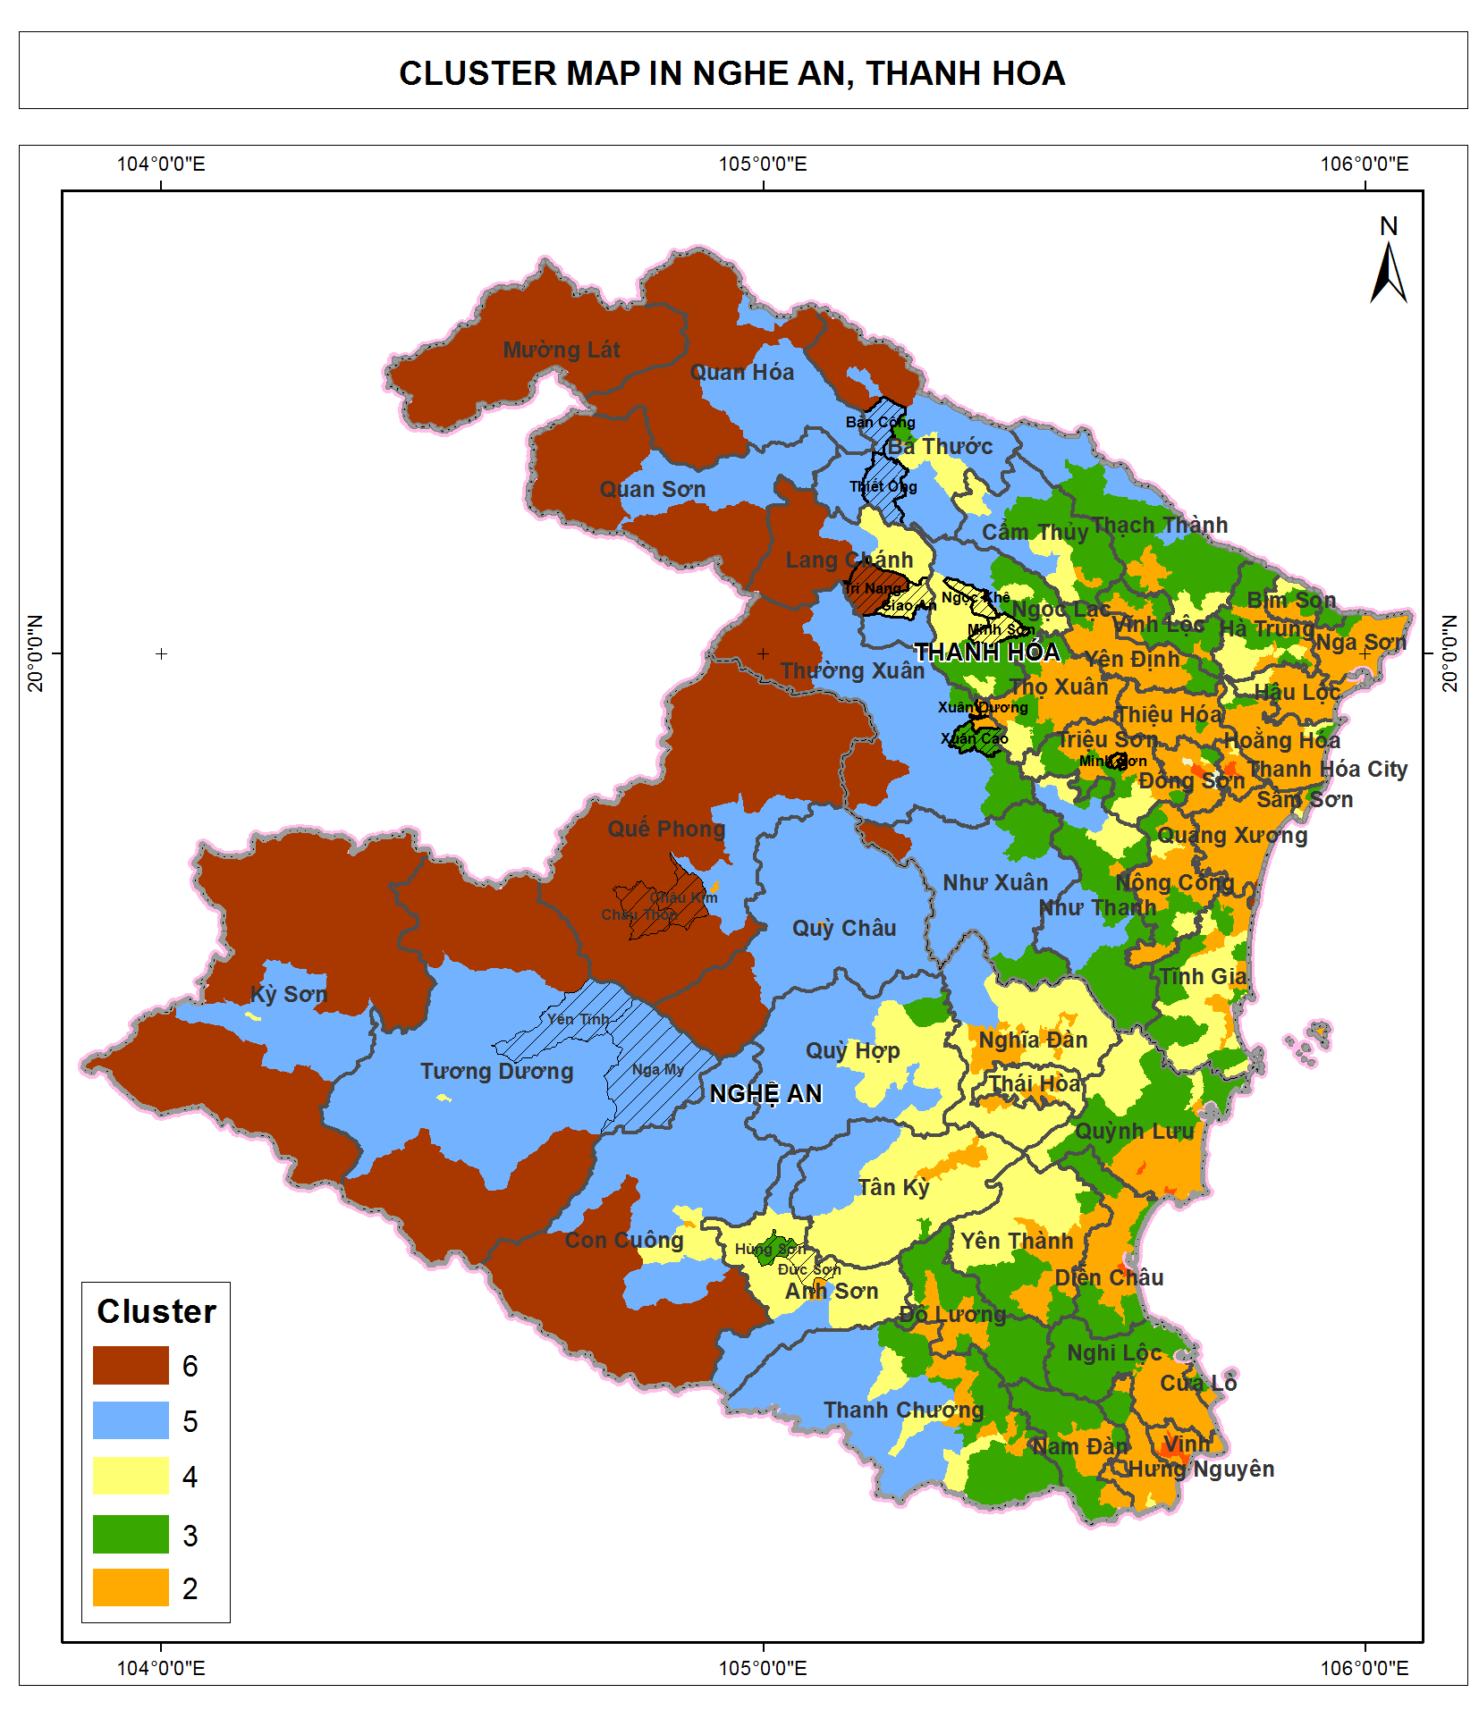

Figure . Map of cluster in Thanh Hoa and Nghe AnAdsfaf

Once the clusters were identified and characterized the communes were selected with advice from provincial VFD officers so that each cluster have at least one communes. The list of commune selected for field survey is presented in Table 3. From each commune, one village is selected with the advice of the commune PPC. From each village, about 15 household is selected with the advice of village’s head so that they represent different type of economic condition: poor household, rich households, household with and without pig raising.

Table . List of commune selected for field survey

|  |  |  |  |  |
| --- | --- | --- | --- | --- |
| **STT** | **Province** | **District** | **Commune** | **Cluster** |
| 1 | Thanh Hóa | Bá Thước | Thiết Ống | 5 |
| 2 | Thanh Hóa | Bá Thước | Bản Công | 5 |
| 3 | Thanh Hóa | Lang Chánh | Giao An | 4 |
| 4 | Thanh Hóa | Lang Chánh | Trí Năng | 6 |
| 5 | Thanh Hóa | Ngọc Lặc | Minh Sơn | 4 |
| 6 | Thanh Hóa | Ngọc Lặc | Ngọc Khê | 4 |
| 7 | Thanh Hóa | Thường Xuân | Xuân Dương | 2 |
| 8 | Thanh Hóa | Thường Xuân | Xuân Cao | 3 |
| 9 | Nghệ An | Anh Sơn | Hùng Sơn | 3 |
| 10 | Nghệ An | Anh Sơn | Đức Sơn | 4 |
| 11 | Nghệ An | Tương Dương | Yên Tĩnh | 5 |
| 12 | Nghệ An | Tương Dương | Nga My | 5 |
| 13 | Nghệ An | Quế Phong | Châu Kim | 6 |
| 14 | Nghệ An | Quế Phong | Châu Thôn | 6 |

## Field survey

***Household fuelwood consumption***

A questionnaire is designed for household interview. The questionnaire include 5 parts, each part include quantitative and qualitative questions. It is designed that some questions are asked for verify answers of other questions. The 5 parts are:

* Part I: General information about household demography, their major income making activities that relate to creating fuelwood or consuming fuelwood. These activities include agriculture cultivation/ afforestation/ pig raising/ alcohol cooking/ other supplement jobs that consume fuelwood. This part also includes questions about the species of forest plantation, and the age of the plants. This is to verify their answers about the source of fuelwood that they are consuming, as in many cases people are reluctant to admit that they collect wood from natural forest. If the answer about the source of fuelwood is that 100% of their fuelwood are from plantation forest, while their plants are acacia at the age of 8 years, then the answer is not verified because they cannot go into the acacia forest for every few days and cut some 8 year-old acacia trees to create fuelwood for their biomass energy need.
* Part II: Information about fuelwood consumption amount; other alternative biomass options; size of fuelwood; other alternative energy options such as electricity and LPG; and the trend in fuelwood consumption whether it is increasing or decreasing.
* Part III: Information about fuelwood collection on how often they collect wood, and the amount of wood for each time they collect wood. Distance for wood collection and time amount for wood collection is to verify the data on amount of each time they collect wood. The answer about amount of wood collected each time and collection frequency is to verify their answer about fuelwood consumption amount. This part also include questions on the trend of availability/ scarcity of fuelwood.
* Part IV: Information about selling wood. This is to understand the fuelwood demand of other sectors.
* Part V: Information about improved stove. This is to understand their actual need for fuelwood saving.

For each commune, one village is introduced by commune officer for household interviews. At each village, at least 15 households introduced by the village head participated in the interview. Given an average village have about 100 to 150 households, the sample size of 15 household for one village were considered as sufficient.

Commune officers (including people’s committee’s representative and/or forest rangers) were interviewed to find out the trend of household fuelwood consumption in the past and near future.

Two restaurants and one primary school were visited for further understanding of residential demand for fuelwood.

***Local industrial consumption***

Seven local industrial plants including three in Thanh Hoa and four in Nghe An were visited for interview and observation for fuelwood demand, including:3 paper mills, 1 MDF, 1 wood chipper and 2 tea plant. Patterned of fuel wood consumption at industrial plan were collected using a semi-structured interview. Key information and questions to be investigated are:

* What is the major product of the plant
* What is the installed capacity
* What is the actual capacity
* The type of thermal equipment: furnace, boiler.
* Type of fuel: fuel wood, coal, oil.
* Quantity of fuel use per day.
* Price of fuel: current and historical; comparison with alternative fuel.
* Trend of fuel demand, future plan for fuel switch and reason.

***Wood middlemen investigation***

The consultant team visited two middlemen, one in Thanh Hoa and one in Nghe An. In-depth interviews were conducted with the middlemen to further understanding commercial demand for fuelwood and actors of fuelwood value chain. Key issue to be investigated with the middleman are:

* Location of exploitation
* Quantity of daily exploitation
* Cost: exploitation, loading, legal document, transportation
* Distance of transportation
* Quality and type of wood
* Selling price

## Data processing and analysis

After collecting all the data, some correction of the data entry errors or logical errors was conducted. During this process the household with very high or very low value compare to their neighbor is selected for reviewing. The survey team revisited the raw questionnaire of those households and discuss the possibility of the value and make necessary adjustment. The questionnaire was designed in such a way that some questions can be used to cross check the the other, therefore if some key questions can be confirmed as correct they can be used to correct the others.

The final database is stored in Excel and is attached to the final report.

# Findings

## Residential fuelwood consumption

### Consumption of residue as an alternative to fuelwood

Of the 14 selected communes there is one, Xuan Duong commune, that use residue extensively as fuel energy. Xuan Duong represent cluster 2, which is most close to delta and farthest to forest. This commune does not have any natural forest and only 6.6 ha of Acacia plantation. With the population of 5,069 the average area of plantation forest of Xuan Duong are 0.0013 ha per person. This number is about 20 time lower than the average forest area per person of 0.03 hectare in Thanh Hoa.

Without the sufficient supply of fuel wood Xuan Duong’s people use residue such as corn cob, Acacia bark and branches to fulfill their biomass energy demand. The data from household interview showed that 80-90% of household biomass consumption in Xuan Duong come from residues. The rest of 10-20% biomass are fuelwood from their home garden. This is necessary to note that not all the Acacia bark used in Xuan Duong are from their own plantation forest. Since this is the flat area people could use motorbike or cart to carry Acacia bark from the neighborhood back to their house. In the case of Xuan Duong, this commune is adjacent to several commune in cluster 3 that have large area of Acacia plantation. In such communes the Acacia bark is abandon therefore people give it away for free.

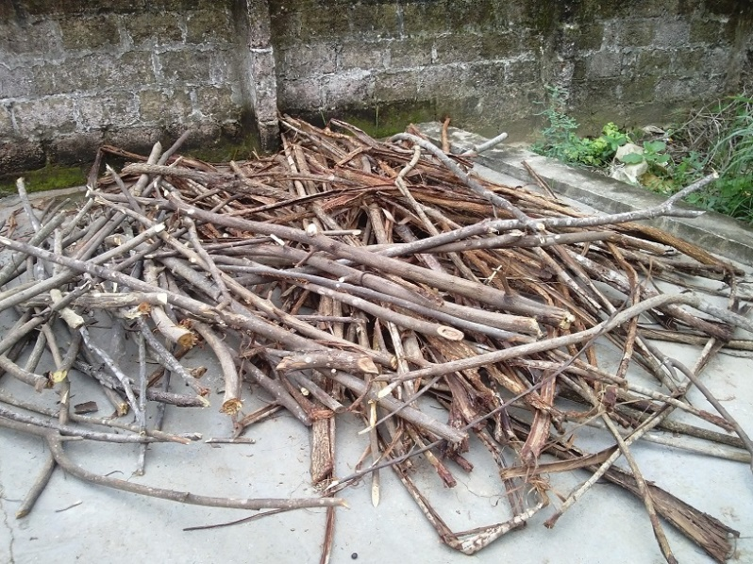

Figure . Acacia bark and Meliaceae branches from home garden

Although the survey do not have resources to study another commune in cluster 2, given the characteristic of cluster 2 is urbanized area with very low coverage of forest, low elevation and flat terrain (Table 3) it could be considered that the majority of communes in cluster 2 is use residues as the main source of biomass fuel.

### Consumption of fuelwood at household

Average household biomass consumption is estimated at 40 kg/person/month in Thanh Hoa and **35 kg/person/month** in Nghe An.

Average consumption by cluster

Average consumption by pig and alcohol

Amongst 215 household interviews of 14 communes, there are 93 households that only use fuelwood for their cooking and heating. The residential fuelwood consumption in cluster 3, where households have more access to urbanization and use of LPG and less access to forest, is about half of other clusters. Cluster 4, 5 and 6 still have access to natural forest within a short distance mostly less than 2 km. Therefore people still use a significant amount of fuel wood for cooking (Table 4).

Table . Wood consumption per person by cluster

|  |  |  |
| --- | --- | --- |
| Cluster | Wood consumption  (kg/ person/ month) | Standard deviation |
| Cluster 6 | 41.6 | 16.2 |
| Cluster 5 | 42.2 | 18.4 |
| Cluster 4 | 39.2 | 18.1 |
| Cluster 3 | 21.4 | 4.6 |

Details of fuel wood consumption by communes is presented in Table 5.

Table . Residential fuelwood consumption, excluding households that raise pigs and have supplement jobs

|  |  |  |  |  |  |  |  |  |  |  |
| --- | --- | --- | --- | --- | --- | --- | --- | --- | --- | --- |
| **STT** | **Province** | **District** | **Commune** | **Cluster ID** | **% householdss with electric rice cooker\*** | **% households with LPG cooker\*** | **% household consuming fuelwood\*** | **Kg of fuelwood per person per month\*\*** | **% small branch of wood and wood size <15cm\*\*** | **% of wood size >= 15cm\*\*** |
| 1 | Thanh Hoa | Bá Thước | Thiết Ống | 5 | 100 | 40 | 95 | 18.00 | 90 | 10 |
| 2 | Thanh Hoa | Bá Thước | Bản Công | 5 | 100 | 20 | 100 | 46.1 | 90 | 10 |
| 3 | Thanh Hoa | Lang Chánh | Giao An | 4 | 70 | 30 | 100 | 45.18 | 90 | 10 |
| 4 | Thanh Hoa | Lang Chánh | Trí Năng | 6 | 95 | 30 | 100 | 49.38 | 90 | 10 |
| 5 | Thanh Hoa | Ngọc Lặc | Minh Sơn | 4 | 100 | 40 | 100 | 60 | 90 | 10 |
| 6 | Thanh Hoa | Ngọc Lặc | Ngọc Khê | 4 | 90 | 40 | 100 | 28.75 | 90 | 10 |
| 7 | Thanh Hoa | Thường Xuân | Xuân Dương | 2 | 100 | 40 | - | - | - | - |
| 8 | Thanh Hoa | Thường Xuân | Xuân Cao | 3 | 80 | 40 | 100 | 28 | 90 | 10 |
| 9 | Nghe An | Anh Sơn | Hùng Sơn | 3 | 90 | 70 | 100 | 14.4 | 90 | 10 |
| 10 | Nghe An | Anh Sơn | Đức Sơn | 4 | 100 | 45 | 100 | 28.33 | 90 | 10 |
| 11 | Nghe An | Tương Dương | Yên Tĩnh | 5 | 5 | 2 | 100 | 66.96 | 90 | 10 |
| 12 | Nghe An | Tương Dương | Nga My | 5 | 50 | 25 | 100 | 68.63 | 90 | 10 |
| 13 | Nghe An | Quế Phong | Châu Kim | 6 | 70 | 13 | 100 | 36.32 | 90 | 10 |
| 14 | Nghe An | Quế Phong | Châu Thôn | 6 | 40 | 5 | 100 | - | 90 | 10 |

\* Data from officer interviews

\*\* Data from household interview

Estimation of wood consumption by commune is as below:

Table . Fuel wood consumption by commune

|  |  |  |  |  |  |  |  |
| --- | --- | --- | --- | --- | --- | --- | --- |
| **STT** | **Province** | **District** | **Commune** | **Cluster ID** | **Population** | **Kg of fuelwood per person per month** | **Estimation of wood consumption (kg/ month)** |
| 1 | Thanh Hoa | Bá Thước | Thiết Ống | 5 | 8283 | 18.00 | 149,094 |
| 2 | Thanh Hoa | Bá Thước | Ban Công | 5 | 6407 | 46.1 | 295,363 |
| 3 | Thanh Hoa | Lang Chánh | Giao An | 4 | 2461 | 45.18 | 111,188 |
| 4 | Thanh Hoa | Lang Chánh | Trí Năng | 6 | 2209 | 49.38 | 109,080 |
| 5 | Thanh Hoa | Ngọc Lặc | Minh Sơn | 4 | 8886 | 60 | 533,160 |
| 6 | Thanh Hoa | Ngọc Lặc | Ngọc Khê | 4 | 10772 | 28.75 | 309,695 |
| 7 | Thanh Hoa | Thường Xuân | Xuân Dương | 2 | 5069 | - | - |
| 8 | Thanh Hoa | Thường Xuân | Xuân Cao | 3 | 5551 | 28 | 155,428 |
| 9 | Nghe An | Anh Sơn | Hùng Sơn | 3 | 3753 | 14.4 | 54,043 |
| 10 | Nghe An | Anh Sơn | Đức Sơn | 4 | 8594 | 28.33 | 243,468 |
| 11 | Nghe An | Tương Dương | Yên Tĩnh | 5 | 3917 | 66.96 | 262,282 |
| 12 | Nghe An | Tương Dương | Nga My | 5 | 4372 | 68.63 | 300,050 |
| 13 | Nghe An | Quế Phong | Châu Kim | 6 | 3938 | 36.32 | 143,028 |
| 14 | Nghe An | Quế Phong | Châu Thôn | 6 | 3442 | - | - |

### Type of fuelwood consumed by household

Most of the fuel wood used for at household are of small size. The data from household interview showed that about 90% of fuelwood use at household has the diameter less than 15 cm. This size of fuel wood is easy to cut down by using machete (a common tool for local people) and transport from forest back to the house. Fuelwood of size 5 cm - 15 cm could be mixed with small branches to make a good fire for cooking.

Below are some pictures that represent the popular size for household cooking.

|  |  |
| --- | --- |
| E:\GFD\02 Ongoing projects\0193 SNV fuelwood baseline\Implementation\Field Trip\Anh\Anh report\CAM02691.jpg | E:\GFD\02 Ongoing projects\0193 SNV fuelwood baseline\Implementation\Field Trip\Anh\Anh report\CAM02661.jpg |
| E:\GFD\02 Ongoing projects\0193 SNV fuelwood baseline\Implementation\Field Trip\Anh\Anh report\CAM02680.jpg | E:\GFD\02 Ongoing projects\0193 SNV fuelwood baseline\Implementation\Field Trip\Anh\Anh report\CAM02717.jpg |

In winter for heating purposes, they would need to cut wood of bigger size so that they can maintain a smoldering fire which can last longer during the day. That explains the demand for 10% of wood size from 15 cm and above.

### Time and cost of obtaining fuel wood

### Source of fuelwood

About 20% of the fuelwood comes from tree from home gardens and scattered wood lots. The rest of fuelwood of about 80% are natural wood, which either comes from daily collecting at natural forests or from harvesting of natural forest which are being converted into plantation forest or to other land use. The legal forest conversion activity provide substantial amount of fuel wood to the market.

Table . Conversion of natural forest to plantation forest and other use (Source, Forest Protection Department 2014)

|  |  |  |  |
| --- | --- | --- | --- |
| Province | Year | Change from natural forest to plantation forest (ha) | Change from natural forest to other land use (ha) |
| Nghe An | 2011 | 2,329 | 370 |
| Nghe An | 2013 | 1,292 | 132 |
| Thanh Hoa | 2011 | 2,387 | 195 |
| Thanh Hoa | 2013 | 1,214 | 11 |

The natural wood provide better quality in term of quality of fire, lasting longer, more energy, and save time for the cookers. Natural species have much higher wood density (WD) than soft wood fast grow plantation species. For example *Madhuca pasquieri* a native species have WD of 1,080 kg/m3 compare to *Acacia mangium* with WD of 590 kg/m3 (Table 9). Higher WD mean higher heat of combustion, therefore with natural wood people can leave the wood in the cooking stove for long time without the need of changing the wood. That mean they have more time to work with other activity.

Table . Wood density of some plantation species and natural species (source Tree and forest allometric equation database of Viet Nam, UN-REDD Viet Nam Programme,2012)

|  |  |  |
| --- | --- | --- |
| **Vietnamese name** | **Scientific name** | **Wood density kg/m3** |
| Keo tai tuong | *Acacia mangium* Willd. | 590 |
| Keo la tram | *Acacia auriculiformis* A. Cunn. ex Benth. | 560 |
| Bach dan la nho | *Eucalyptus tereticormys* Sm. | 780 |
| Xoan đào | *Prunus arborea* (Blume) Kalkm. | 620 |
| Go do | *Afzelia xylocarpa* (Kurz) Craib | 830 |
| Lat hoa | *Chukrasia tabularis* A. Juss | 680 |
| Lim | *Erythrophleum fordii* | 930 |
| Sen mat | *Madhuca pasquieri* (Dub.) H. J. Lam | 1,080 |

There are 3 main types of plantation trees in the area of survey: bamboo, Acacia, and Lát hoa (Chukrasia tabularis A.Juss). In Ba Thuoc and Lang Chanh and part of Ngoc Lac district of Thanh Hoa province, most plantation forest are bamboo. In the 3 districts Anh Son , Tuong Duong, Que Phong of Nghe An province Acacia is widely planted to produce chips for paper material.

At the households that have bamboo plantation forest, they utilize the lowest part of bamboo trunks (0.5-1m above the ground) and tops of bamboo for cooking. At the household that have Acacia plantation forest, people use only a small amount of Acacia branches for cooking because it creates a lot of smoke that discomforts and may cause health issues.

During the survey there is only one restaurant that use Acacia wood for cooking. This restaurant use a cooking stove that have the chimney to take the smoke outside.

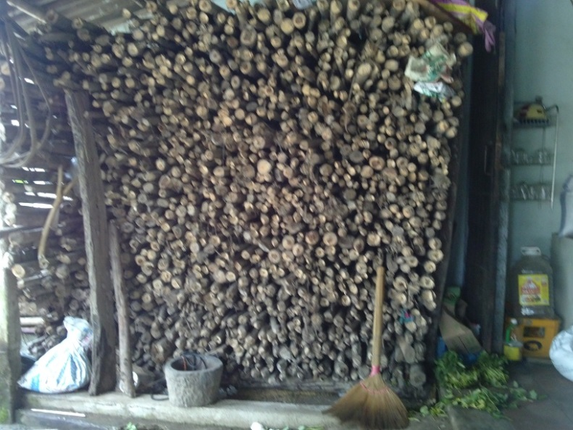

Figure . Acacia wood at a restaurant in Lang Chanh town

### Fuelwood for pig raising

For the upland area where pig only eat cooked feed, household reported to use 40 kg fuel wood/pig/month for pig rising. This is the average consumption during one raising cycle in 5 months. During the month from 3rd to 5th it could require as much as 80 kg/pig/month, therefore create a big demand for fuel wood for household that raise more than 10 pigs per year.

In lower land area, such as Hung Son, Duc Son commune of Anh Son district, half of pig feed is cooked by fuelwood and the other half is from commercial ready animal feed which does not require cooking. Therefore the consumption of wood per pig head at the low land is much less than the upland. [need data here]

***Trend for fuelwood consumption for residential demand***

As economic conditions are gradually improved, the households tend to buy electric rice cooker to save time for cooking. The cost for electricity needed for cooking is affordable for most households. The average cost for electricity rice cooking for one household is about 30,000-50,000 VND/month. For the household that have better income and easier access to LPG suppliers, they tend to use more LPG for cooking. The cost for LPG is from 70,000 VND to 150,000 VND per month.

In the future when most household buy and use rice cooker and LPG cooker, the demand for fuelwood for cooking will reduce gradually. However, the people will remain using fuelwood for at least coming few years, as it is of long-time tradition, and it is a source of free energy available.

***Improved stoves***

For households that consumed fuelwood only for cooking, the residents tend not to be interested in improved stoves. They think that there are plenty of wood and so saving wood is not much helpful in their daily activities.

However for the households that consumed fuelwood for pig feed cooking and has supplement jobs, people are more interested in the improved stoves.

***Gender issue in fuelwood collection and cooking***

In the households that have buffalos, fuelwood collection is assigned to the persons who is in charge of herding buffalos. More men are assigned to look after buffalo therefore they usually in charge of fuelwood collection.

There are more women assigned to cooking than men. But this trend is not very obvious since in more than half of the household surveyed, both the men and women are involved with cooking.

## Local industrial consumption

Neu tom tat’ ve so cac nha may da khao sat

Cac bang thong ke ve loai san pham, khoi luong san pham, luong nhien lieu tieu thu trong cac nha may

***Distance of fuelwood consumption for local industrial***

The fuelwood are transported within a distance of 50km from the collection site to the industrial plants. If the wood are transported longer, the cost for transportation will increase which make the selling price increase.

Therefore the industrial plants that consume fuelwood are those which are located close to the natural forest. Within this distance, the price of wood per calorific value is cheaper than that of coal. It was observed that a paper mill located in Lang Chanh buy fuelwood from Lang Chanh district, while a MDF plant located in Nhu Xuan district right at the boundary between Thanh Hoa and Nghe An buy fuelwood from Quy Hop district, Nghe An prvoince. A tea plant in Thanh Chuong district purchase wood transported from adjunction district in Ha Tinh province and Laos.

If the distance from industrial plants to fuelwood source is longer than 50 km, they prefer to use coal because the price of coal is more competitive in terms of calorific value. For example surveyed paper mills in Lam Son (Thanh Hoa) and Hung Son (Nghe An) are using coal for their boilers. These plants have tried to use fuelwood before but then had to switch back to coal because the cost for fuelwood is higher.

***Price of fuelwood selling to local industrial plants***

The average price of fuelwood selling to local industrial plants is 650,000 VND per ton. It is not possible to identify all species of fuelwood, so it is assumed that the average calorific value of wood (at moisture of 0%) is 4,000 kcal per kg and the actual moisture is at about 35% (wood partly dry since logged). Based on this assumption the price per energy unit of fuelwood is 0.2 VND per kcal.

This is to be compared with coal price sold at lower land of Thanh Hoa and Nghe An. The price of coal with calorific value of 7,500 kcal/ kg is about 3,800 VND per kg, and dust coal for calorific value of 5,600 kcal/ kg is about 1,950 VND per kg. The prices of coal and dust coal per energy unit are 0.5 VND per kcal and 0.35 VND per kcal respectively.

Therefore the industrial plants close to forest prefer to use fuelwood to coal.

Below are the pictures of fuelwood at industrial plants.

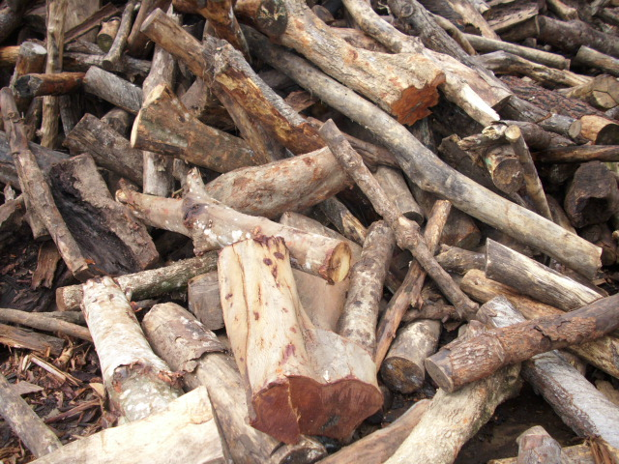



## Commercial activities of middlemen

***Distance of commercial wood***

Commercial fuelwood are transported within a distance of 50km. Within this distance, the transporters are very familiar with roads, and traffic police routines. They can avoid police check on transport weight, and transportation legal document. Wood trucks are often over weighted: for example for a truck of 20 ton of load permit, it often carries 42 – 43 tons of wood. Transportation documents are often insufficient: for example it lacks of exploitation permits or commune verification.

Further than 50km, there is high potentiality of police punishment due to law violation including overweight transportation, lacking of proper transportation documents. The punishment rate is very high, up to 15.000.000 VND per truck of 42 tons of wood (for a truck of 20 tons of load permit), and the truck could be kept by the police for 30 days. It would lead to an increase of 375.000 VND per ton of wood, not including the vehicle keeping cost by the police. While the normal selling price is about 1.000.000 VND per ton of wood (for a distance of 250km from the wood source), the occurrence of costs of 375.000 VND/tons is significant that the middlemen do not choose to take the risk.

***Source of commercial wood are natural wood***

During the survey it was observed that 100% of fuelwood for commercial activities are natural wood. The reason is that the price of planted wood (Acacia) to sell as paper material is higher than natural wood. The price of Acacia at collection site at district (without transportation cost) is 750.000 – 850.000 VND per fresh ton after peeling the bark (right after cutting down, most of moisture is still contained), while the price of natural wood at collection site at district is from 500.000 to 550.000 VND per ton for partly dry wood (2-3 weeks after cutting down).

***A significant amount of natural wood is exploited from forest conversion***

The source of these natural wood are either from existing natural forest or harvesting of natural forest that are converted to plantation forest and other land use. For example in 2013, 1292 hectares of natural forest in Nghe An and 1214 ha of natural forest in Thanh Hoa have been legally converted to plantation forest (Source: Department of Forest Protection, 2013). For these forest conversion, harvesting of natural wood is allowed by the laws[[2]](#footnote-2). This forest conversion is a large source of natural wood to the market. The below picture shows the natural wood logged from converted forest.

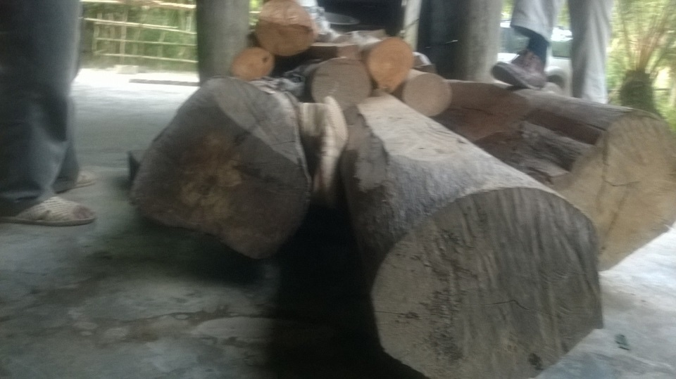

***Size of commercial wood***

The commercial fuelwood supplied to the industrial plant by the middleman in Quy Hop district include about 10% of wood with diameter 25-30cm, 60 to 70% of wood with diameters of 15-25 cm, the rest of 20 to 30% of wood with diameter 10-15cm. These are the sizes and ratio which is suitable for transportation and combustion at industrial boilers.

## Discussion of total fuelwood consumption

Within the scope of this research, it is not allowed to conduct a full primary survey of local industrial fuelwood consumption. Instead, only selected plants were investigated including:

* In Thanh Hoa: 1 paper mill, 1 wood chipper, 1 MDF plant
* In Nghe An: 2 tea plants, 2 paper mill

A full picture of mixed fuelwood consumption including residential and commercial consumption is very much depending on specific residential – industrial – commercial consumption models. Therefore specific sites are selected for consumption analysis.

Two districts, one for each province have been identified as the most active fuelwood trading activities. For Thanh Hoa it is Lang Chanh district, for Nghe An it is Quy Hop district. These two districts have cluster 4, which has the characteristics of lower hills and mountain, less natural forest, more plantation forest, easier access to main roads (which means more commercialized), medium population density. In other words, it means that these two districts are in the middle between forest (cluster 6 and 5, mountain area) and delta (cluster 3 and 2, low land).

### Discussion of fuelwood consumption in Lang Chanh district, Thanh Hoa

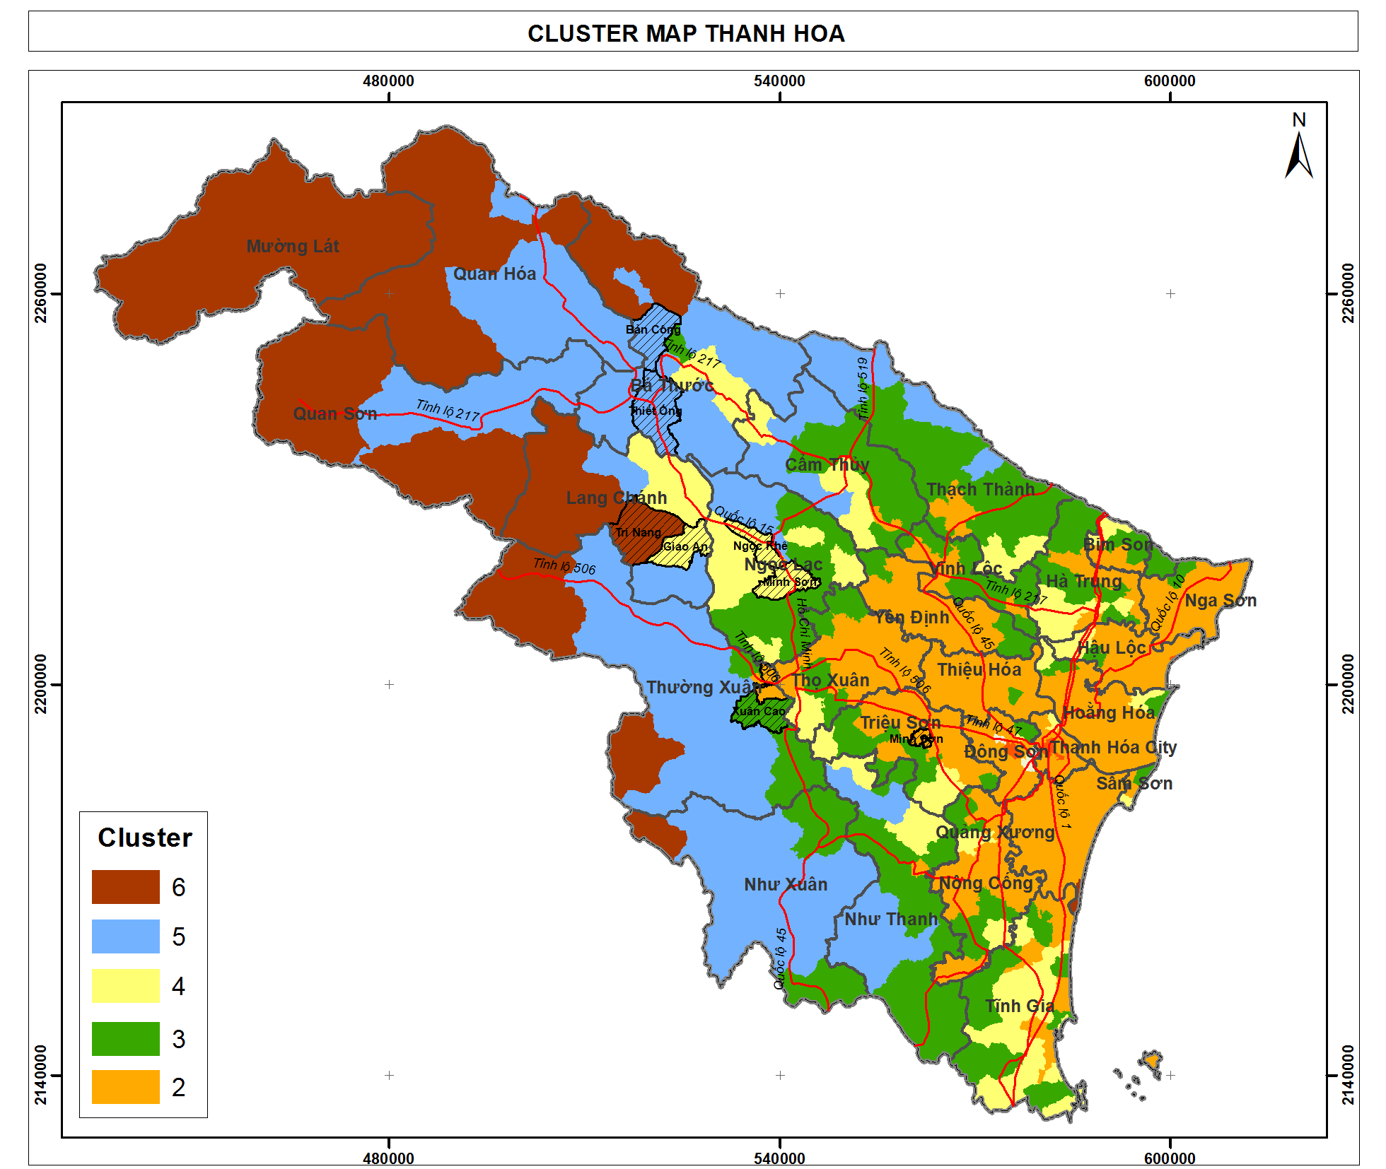*Cluster map of Thanh Hoa province*

***Residential wood consumption***

Lang Chanh is a district of Thanh Hoa province, which has a population of 43,913 person. Natural area is of 5,846 km2. Population density of 7.51 person per square kilometer. This population density is low compared to average density of Thanh Hoa province of 32.1 person per square kilometer.

Lang Chanh has average natural forest per capita of 0.67 hectare/ person and plantation forest per capita of 0.28 hectare/ person (compared to 0.11 and 0.03 of Thanh Hoa province).

Table . Demography of Lang Chanh district, Thanh Hoa

|  |  |  |  |  |  |  |  |
| --- | --- | --- | --- | --- | --- | --- | --- |
|  | Population | Area (ha) | Density person/km2 | Natural forest area (ha) | Plantation forest area (ha) | Area of natural forest per pax | Area of plantation forest per pax |
| Thanh Hoa | 3,557,482 | 1,108,239 | 32.10 | 381,220 | 110,968 | 0.11 | 0.03 |
| Lang Chanh  District | 43,913 | 58,463 | 7.51 | 29,347 | 12,151 | 0.67 | 0.28 |

Lang Chanh district include 3 cluster 4, 5, and 6. Residential fuelwood consumption of Lang Chanh is estimated in the table below.

Table . Residential fuelwood consumption of Lang Chanh

|  |  |  |  |  |  |
| --- | --- | --- | --- | --- | --- |
| Item | Unit | Cluster 6 of Lang Chanh | Cluster 5 of Lang Chanh | Cluster 4 of Lang Chanh | Lang Chanh district |
| Population | Person | 15,666 | 7,423 | 20,824 | 43,913 |
| Wood consumption per person per month (from Table 4) | kg | 41.6 | 42.2 | 39.2 |  |
| Wood consumption per person per year | kg | 499 | 506 | 470 |  |
| Total wood consumption per year | Ton | 7,817 | 3,756 | 9,787 | 21,360 |

Based on this assumption, total fuelwood consumption of Lang Chanh is about 21,000 tons per year. While this number is much larger than the total commercial fuelwood demand (to be mentioned below), it needs to note that only 10% of this amount is of size larger than 15 cm. That means about 2,100 tons of wood size larger than 15 cm are consumed by household of Lang Chanh district.

***Commercial wood consumption***

It is found out that there are 3 biggest wood middlemen in Lang Chanh. Each middleman works in several communes to buy wood exploited from natural forest. They buy wood from the villagers and sell to industrial plants within the distance of 50km. Based on actual demand of the plants, they will order the villagers to log wood from the forest. The total daily exploited amount of all the three middlemen in Lang Chanh is about 14-15 tons per day, for about 300 days a year.

As this fuelwood will be transported and to serve the boilers or furnace of industrial plants, the size of the wood is requested to be bigger (for transportation purpose) and the quality of wood required is higher than the quality of wood consumed by households. According to one middleman, the ratio of wood size of these fuelwood is that 20-30% of size 10-15cm, 50-60% of size 15-25cm, and 10% of size 30 cm and above. Total ratio of wood size from 15 cm and above is therefore about 70 %.

It is estimated that the demand for fuelwood for commercial purpose at Lang Chang is 4,500 tons/year in which 1,350 tons of size 10-15cm and 3,150 tons of size larger than 15 cm. Comparing that with 2,100 tons/year of size larger than 15 cm consumed by households (10% of total consumption), it is estimated that that the commercial demand is contributing to 60% of large size natural wood demand in total consumption, while residential demand is contributing to about 40% of that comes from the demand of heating of residents.

***Trend in fuelwood consumption in Lang Chanh***

While it is seen that the trend for fuelwood consumption by households is decreasing because of increasing electric rice cooking and LPG cooker, there is no evidence that the demand for industrial wood in the region will decrease. In fact, the industrial plants surveyed are operating at 60-70% of installed capacity due to economic crisis. When the existing plants are operate in full capacity, the demand for fuelwood for industrial plants may even increase.

### Discussion of fuelwood in Nam Son commune, Quy Hop district, Nghe An

Quy Hop is a district located in the middle the main roads from higher mountainous area to the low land of Nghe An province. Wood trading activities are crowded in Quy Hop.

Table . Demography of Nghe An province, Quy Hop district, Nam Son commune

|  |  |  |  |  |  |  |  |
| --- | --- | --- | --- | --- | --- | --- | --- |
|  | Population | Area (ha) | Density person/km2 | Natural forest area (ha) | Plantation forest area (ha) | Area of natural forest per pax | Area of plantation forest per pax |
| Nghe An | 2,943,901 | 1,651,378 | 17.83 | 656,341 | 105,691 | 0.22 | 0.04 |
| Quy Hop  District | 119,960 | 93,934 | 12.77 | 28,278 | 5,836 | 0.24 | 0.05 |
| Nam Son Commune | 1633 | 6,377 | 0.39 | 3,754 | 52 | 2.3 | 0.03 |

Nam Son is a commune of Quy Hop district, where the average area of natural forest per person is very high: of ten times of that of Quy Hop in particular and of Nghe An in general (see above table).

In Nam Son commune, there is one middleman who run wood trading activities of the whole commune. Nam Son commune has a rather high rate of average natural forest are per person. In the last 2 years there is a large forest conversion in the commune where poor natural forests are converted to Acacia plantation. Natural forest are assigned to household for forest conversion. During this period, there is an activity of harvesting wood from natural forest. All natural trees are logged to prepare empty land for plantation.

The middleman in Nam Son commune buy all logged natural wood and sell to an MDF in Nhu Xuan district of Thanh Hoa. On average he sells about 7 tons of that natural wood collected from converted forest that plant. For a commune of 3,754 hectare of natural forest, exploiting 7 tons a day is much higher speed than that of Lang Chanh district, where the area of natural forest is 29,347 ha and exploiting 15 tons per day. It is because the converted forest area of Nam Son commune is of much higher quality (the natural forest is much richer) than that of Lang Chanh district in Thanh Hoa.

According to the middleman, the ratio of wood size that he collect is that 60-70% of size 25cm and above, and the rest 30% is of size 15-25cm. This is to be compared with the middleman in Lang Chanh district of Thanh Hoa, where only 10% of size 25 cm and above, which shows that the quality of natural wood exploited in Nam Son is of much higher than than of Lang Chanh district.

The middle man also said that these wood are legal because this is from harvesting of natural forest for forest conversion. However, he also understands that it is very difficult to transport these woods too far. Therefore he only sells in the distance of 50 km. The picture below shows the natural forest being converted to acacia plantation.

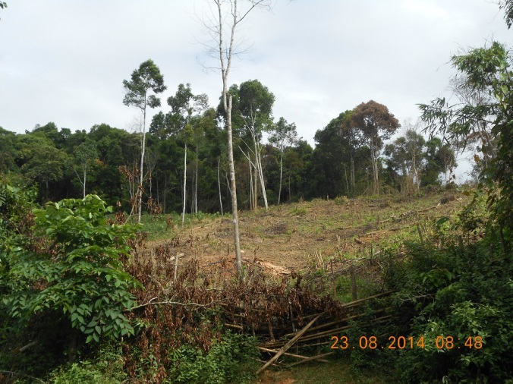

At this exploitation speed of about 7 tons per day, this middleman is collecting about 2,000 tons of wood size 15 cm and above every year.

Nam Son commune is of cluster 3. For a population of 5499 people for the demand of 21.4 kg of fuelwood per person per month, the total demand for the commune per year is 1,485 tons of wood per year for household cooking, in which 90% are of wood size less than 15cm. This means the amount of wood size more than 15 cm for residential demand is only 148 tons per year, compared to 2,000 tons of wood size 15 cm and above collected by the middleman to be sold to industrial plants. The consumption of residential demand is only 5-6% of large wood of 15 cm and above.

**Discussion of local industrial plants’ fuel wood demand of Nghe An and Thanh Hoa**

Interview at the MDF plant (located in Nhu Xuan district, Thanh Hoa province) that the middleman in Nam Son commune mentioned shows that the plant purchase 200 tons of wood per day, in which 90% is for MDF materials, and 10% is for fuelwood for its boiler. That means every day the plant consumes of 20 tons of fuelwood. Most of the wood (material and fuel) are from Nghe An and from forest conversion activities as described by the middleman in Nam Son commune. The manager of the plant worries that in the next 2-3 years, this source of wood will run out and the plant will face difficulties in purchasing wood as the price of plantation wood (acacia) is 30% higher than the price of current wood purchased. When asking if the manager is interested in saving 10% of cost of fuelwood by improving operation to increase efficiency, the manager says that he is not interested because 10% of fuel cost take only a very small portion of the total product cost.

Below are some pictures of the wood at the MDF plant.

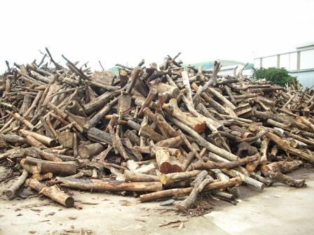

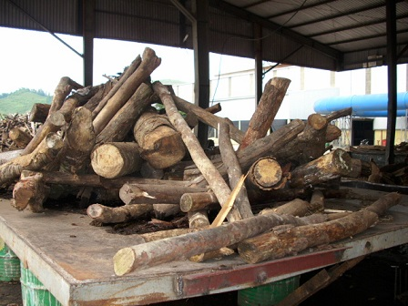

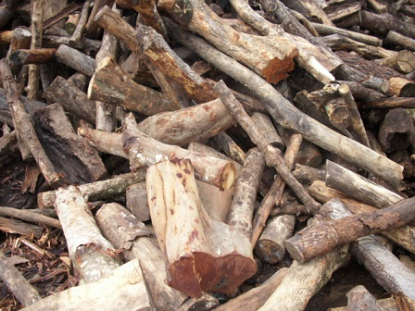

Two tea plants, on in Thanh Chuong district and one in Anh Son of Nghe An were surveyed about fuelwood demand. These districts are located further down to delta of Nghe An province.

For the tea plant in Thanh Chuong district, total installed capacity of this plant is 25 tons of fresh tea per day. At the moment the plant is operating at the capacity of 12-15 tons of fresh tea per day (4-5 tons of dry tea per day) and is consuming 29 – 35 tons of wood per day. This means that every ton of dry tea need 7,3 tons of fuelwood (natural wood). 3 years ago they used dust coal fired furnace to dry the tea. But since 2011 they switched to wood firing because it helped saving up to 30-35% of the cost. The wood they bought are from Laos and Ha Tinh province because the distance of transport from Laos and Ha Tinh are closer than from other area of Nghe An (within 50km).

According to the director of this plant, there are 6 other tea plants of the same size or bigger than this plant in Thanh Chuong district. They all used fuelwood for drying tea. It is therefore assumed that at least 200 tons of fuelwood are consumed per day at tea plants of Thanh Chuong district.

|  |  |
| --- | --- |
| E:\GFD\02 Ongoing projects\0193 SNV fuelwood baseline\Implementation\Field Trip\Anh\Anh report\WP_20140823_006.jpg | E:\GFD\02 Ongoing projects\0193 SNV fuelwood baseline\Implementation\Field Trip\Anh\Anh report\WP_20140823_003.jpg |

*Fuelwood for furnace for tea plant at Thanh Chuong district*

Two paper mills, one is Song Lam paper mill in Hung Nguyen district of Nghe An province, and the other is Muc Son paper mill in Tho Xuan district of Thanh Hoa province were surveyed on fuelwood demand. Both these two plants are using coal and dust coal for their boilers. According to the managers, they have tried to use fuelwood several years ago, but the cost of using fuelwood is higher than that of coal.

It is noted that Hung Nguyen district of Nghe An and Tho Xuan district of Thanh Hoa both belong to cluster 2 of which the characteristics are highly towards ‘delta’. Therefore it is assumed that fuelwood is not a popular energy source for delta area. Instead they use coal which is more traditional, easy to access, and price competitive.

**Discussion of a general picture of fuelwood consumption in Thanh Hoa and Nghe An**

From the survey it is found out that the fuelwood are only transported within the distance of about 50km from the forest source. Longer distance of transport will cost higher, and take more potential transport police punishment. Therefore there is not a further supply chain of fuelwood because of incompetency in price.

Lack of detailed survey on local industrial plants’ demand for fuelwood leads to a less precise estimation of proportion of industrial consumption and residential consumption. However, there is a clear picture that commercial wood in the area are only to supply to local industrial plants, that take 60% and more of large natural wood (size 15cm and above). This ratio may even increase when the manufacturing sector recovers from economic crisis.

## Value chain assessment in relationship to forest degradation and deforestation

Charcoal is not popularly used in the area of research. In fact, among 215 households surveyed and 6 plants visited, none of those use charcoal as a source of fuel. Therefore charcoal is not included in the survey and in the value chain assessment.

The below chart represent the value chain of fuelwood in Thanh Hoa and Nghe An

|  |  |  |  |  |
| --- | --- | --- | --- | --- |
| **Actor** | **Activity** | **Location** | **Income (VND/ ton)** | **Value (VND/ ton)** |
| Farmer/ Wood logger | Logging wood | Natural forest near truck road | 140,000 | 140,000 |
| Wood collector | Carry and upload wood to truck | Collection Site (truck road) | 150,000 | 290,000 |
| Middleman | Prepare transportation license, letter of origin | Commune Office | 180,000 | 470,000 |
| Transporter | Transport | Distance 50 km | 180,000 | 650,000 |
| Industrial Plant |  |  |  |  |

The value chain of fuelwood is as below:

The farmers are hired by the wood collector to log wood from the forest for a wage of 140,000 VND per ton. The wood collector upload the wood on a farm vehicle and carry to a truck road, where the truck is waiting. He then upload the wood on the truck and sell them to the middleman for 290,000 VND per ton. The middleman is responsible for preparing transport documents for the wood and get verified by the commune rangers. Then the middleman hire a transporter to sell the wood to the industrial plant for 650,000 VND per ton. The middleman pay the transporter for 180,000 VND per ton for 50km of transportation. He is making 180,000 VND per ton of wood.

If the natural forest is 2km from truck road, then the wage for the wood logger is only half, of 70,000 VND per ton of wood. The wage for carry wood for 2km from the forest to truck road is 70,000 VND.

There are no further chain outside of local industrial demand, no further commercial activities of transporting wood outside of the provinces.

**Discussion of forest degradation and deforestation**

While deforestation is not very obvious as natural forests are converting to plantation forest (so forest area is not decreased), it is clearly that forest degradation is under great pressure of fuel wood demand and land conversion.

Vast land conversion (from natural forests to plantation forests) in some specific areas of Nghe An is causing lose of rich and medium natural forest. This is to plant acarcia for paper materials, which has higher value than fuelwood.

Fuelwood consumption of both industrial sector and residential sector is also creating pressures on fuelwood supply. In which, consumption of industrical sector take a bigger proportion of demand (60%) and tend to increase, while consumption of residential sector take a smaller proportion of demand (40%) and tend to decrease.

# Recommendations

## Urgent need for revision of land conversion in some specific area

The forest land conversion from natural forest to plantation forest to develop acacia trees for paper materials needs to be revised carefully. While selling acacia may lead to a direct increase in income of farmers and households as the price of acacia is higher than the price of natural wood to be sold as fuelwood, a vast plan for this conversion may cause a serious and large scale of forest degradation.

It is recommended that forest inventory in Nghe An should be taken more precisely that will help categorizing natural forest more precisely and developing better conversion plan.

## Urgent need for forest land administration in some specific area

The main cause of deforestation is shifting cultivation on the upland area. In Tuong Duong district the upland farm is only recorded on the document but there is no parcel map and no official land certificate for this type of land use. Each year every household will clear 1-2 ha of regrowth or poor forest to growth corn and rice. This process is repeated every year on the large scale is the largest thread in deforestation. Because the shifting cultivation farm is a land use category recognized by local government the people have the right to use this type of land for agriculture cultivation. Since there is no clear boundary and no parcel map, it is very difficult to give punishment to households that encroaching into forest because the location and boundary of his land cannot be identified in the first place.

It is recommended that a budget should be allocated for mapping of cultivation land and forest land in some specific area of Nghe An, such as Tuong Duong district. The picture below shows the shifting cultivation on the area of natural forest in Tuong Duong.

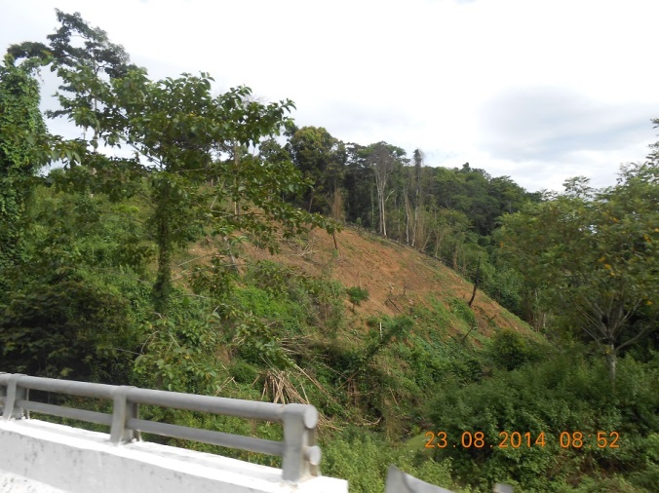

## Improved stoves

A program of improved stoves could be introduced to selected households that raise pigs in a big quantity and that have to buy wood not collected for free such as in Xuan Cao commune of Thuong Xuan district, Thanh Hoa, and Hung Son, Duc Son commune of Anh Son district, Nghe An. To these households, saving wood is relating to saving costs. Therefore improved stoves program may have more opportunity for success.

Improved stoves could also be introduce to household that has supplement jobs such as alcohol cooking and taufu making.

This could lead to less demand for fuelwood.

## Stability of electricity supply

Access to a stable electricity supply may also encourage households to use alternative energy so that the demand on fuelwood may decrease.

In Ngoc Khe commune of Ngoc Lac district, Thanh Hoa, the commune officer said that due to electricity unstable, many electric rice cookers of households have broken, that lead them to go back to the traditional energy of fuelwood.

Therefore stable electricity supply could be considered to reduce pressures on fuewood demand.

***Promotion of electricity-saving cookers***

Promotion of electricity-saving cookers could also be considered as a solution to reduce fuelwood cooking dependence. People are already aware that electric rice cooker is time saving and cost-affordable. Therefore an introduction of electricity-saving cookers with a promotion program can encourage them to use more electric cooker and less fuelwood.

## Training on natural forest management skills for households

About 90% of fuelwood consumed by households are of the size less than 15 cm. 70% of these are from natural forest. While it is not possible to stop this demand immediately, a training on natural forest management skills for households may improve the situation.

Natural forest being properly managed by thinning and cutting down the low-quality trees or unused trees that may compete with good timber trees. That operations will lead to a better development for valued timber tree species (size 15cm and bigger) and will create a considerable amount of fuelwood. Previouse reports have estimated that each hectare of natural forest can sustainably provide at least 1.2-1.5 tones fuelwood per year from operation of thinning and cutting shrub.

Therefore a training program should be conducted for households, so that help them to collect quality wood from natural forest, while also taking care for values trees in natural forest.

## Potential of using agriculture residues as an alternative to fuelwood

There is a potential of using agriculture residues to fulfill a significant amount of biomass energy demand. A program to encourage people switching from fuelwood to agriculture biomass could be considered as a solution to reduce fuelwood consumption.

## Creation of fuelwood source

As the demand for fuelwood will not decrease significantly in coming years, a program of activities for planting fuelwood should be considered to create fuelwood for the future. Selected tree species that grow fastly and provide high quality of wood could be considered for plantation including Melia Azedarach, Eucalyptus Camaldulensis. Commune land and unused land might be used for this purpose.

1. R. Johnson and D. Wichern (1992). *Applied Multivariate Statistical Methods*, Third Edition. Prentice Hall. [↑](#footnote-ref-1)
2. Circular 35/2011/TT-BNNPTNT dated 20th May, 2011guiding on exploiting, taking full advantage of timber and NTFPs. Circular 23/2013/TT-BNNPTNT dated 4th May, 2013 of the MARD to improve extremely poor natural forests which are production forests [↑](#footnote-ref-2)